

**ENGLISH HL 30 August 2025**

**GRADE 12 PAPER 3 – LONGER TRANSACTIONAL CATEGORY B & C**

**CATEGORY B & C - Formal/Informal Report, Review, Newspaper/Magazine Article/Editorial**

**Agenda and Minutes of a Meeting, Obituary**

**OBITUARY**

An obituary is a notice of the passing on of someone known by the target audience.

Over and above ‘formally’ announcing the death, it also sketches the cause of death as well as the funeral arrangements. The obituary is written in the third person.

**Obituary Template**

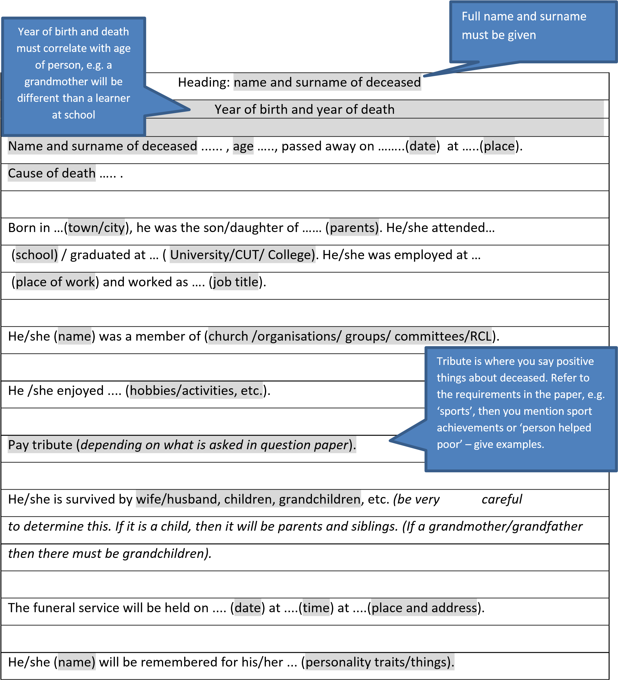

In lieu of the passing of …. (Person’s Name) flowers will be accepted in remembrance.

*Errors made by learners:*

* Some responses were presented as eulogies/newspaper reports/funeral notices.
* There was also a tendency to write a generic obituary and merely adding the information from the question.
* Learners write in the first person.
* Details pertaining to the topic were ignored or mentioned vaguely.

|  |  |  |
| --- | --- | --- |
| **The aspects below must be included:** | **Some of the following may be included:** | **Style and tone** |
| * full name of the deceased * date of birth, date of death * where person was living at time of death * birthplace * key survivors and their names * time date place of funeral * a tribute | * cause of death * biographical information | * formal tone * concise * euphemisms may be used, e.g. *passed away* instead of *died* |

**OBITUARY**

**SIMBA MHERE**

**29th October 1988 – 17 August 2019**

*Top Billing* mourns the tragic loss of presenter Simba Mhere. The news of his untimely passing has been received with immense shock and distress by his friends, fans and colleagues.

Simba Mhere was born on the 29th October 1988 in Zimbabwe at Harare General Hospital to missionary parents Joseph and Angela Mhere from Tafara Township. Simba was 23 months old when his parents relocated to Johannesburg, South Africa, where they served as full time missionaries at Jesus Alive Ministries.

His primary school years were spent at Rhema Christian School. He completed his high school career at Randpark High where he excelled in leadership, rugby and athletics. Simba joined University of

Johannesburg and studied B Com Accounting but he had a calling to entertain. In 2010, in his 3rd year at UJ, he auditioned for the *Top Billing* presenter search and went on to eventually win the coveted TV presenting position.

In his four years on *Top Billing*, he made friends with local, international celebrities and fans alike. As the youngest member of the *Top Billing* team, he enjoyed the opportunity to travel the world. He was an asset to *Top Billing* and a role model to many South Africans.

**MAGAZINE AND NEWSPAPER ARTICLE**

A magazine or newspaper article is written to inform, persuade and entertain. The style and tone of an article is determined by purpose, audience and the issue being addressed. For example, an article written for a school magazine will differ from an article written for a local newspaper or magazine.

**POINTS TO REMEMBER WHEN WRITING A NEWSPAPER ARTICLE**

* Focus on human interest- the tone and emotion you put into the article make it either boring or interesting.
* Write in Active Voice
* **Heading** – Immediately gives idea about what passage is about. Heading should be attention grabbing and visually interesting. E.g. ***Breaking Boundaries / Unleash your Potential***
* **Introduction –** Hook reader (drama, emotion, quotation, rhetorical questions, descriptions, alliterations, metaphors) Who/What When/Where/Why
* **Body**- Stick to ideas introduced, if possible, try to answer questions raised.
* **Conclusion** – Help reader remember key points. Use a strong punch line.
* Always use paragraphs – you don’t need to write in columns as used bin newspapers.
* Write in the THIRD PERSON – he, she, it, they
* Be OBJECTIVE Use ACTIVE VERBS- reader can be immersed in what is being said.
* The STYLE should be lively, neutral or informal, speaking directly to the reader. It can be descriptive and figurative, appealing to the imagination of the readers.
* Consider the purpose before writing the article. The purpose will determine the style of the article. Will it be lively, serious, informal, entertaining? The purpose will help you determine how much fact and opinion the article will have.

**Secrets you should know about teens**

Teenagers have worked hard to convince adults that they don’t want them “butting into their lives”.

On the surface this is true. But deep down they do want to share their fears and dreams with their parents. The main reason they don’t just open up is that parents discourage frankness with judgements and lectures.

Teens are biologically driven to be different from their parents. The problem, psychologically, is that they don’t know what they want to be instead. The challenge is to get to know teens gracefully without raising their defences and share with them some of the wisdom parents have learnt since adolescence.

Perhaps the most startling secret of all is that teens want limits to be imposed on them. One teen, whose mother died of a drug overdose and who had lived a very unstructured life told me that he liked having his foster mother put limits on him. He stated that this is what it felt like to have a “mom who cares for you”

Parents are big on demanding that teens be respectful but they neglect the reality that teens want respect too. The truth is that most teens don’t respect adults because they don’t feel respected. Common courtesies, such as ‘thank you” or knocking on their bedroom door before entering, are simple ways to respect a teen.

Teens perceive the world with emotionally charged lenses. As their hormones kick into high gear, they go from feeling on top of the world to depressed all in a matter of moments. The more parents understand that ebb and flow of teen energy the better they will cope.

*Adapted and shortened from a column by family therapist Ron Huxley*

**THE INFORMAL REPORT**

A report is usually required on an important phenomenon or incident that requires some action, usually by a person or body of authority. The report, whether formal or informal, is always written factually and objectively. You should therefore AVOID

* using subjective language;
* making unsubstantiated claims; and
* using emotive language.

The Formal Report should be written in the third person. Be concise

**EXAMPLE OF AN INFORMAL REPORT**

REPORT ON: EYE WITNESS ACCOUNT OF A FIGHT BETWEEN TWO LEARNERS OUTSIDE THE SCHOOL GATE

TO: Mr P. Reddy – Deputy Principal

PREPARED BY: Nkosinathi Bhengu – Grade 12 G

DATE OF SUBMISSION: 2 February 2019

On Wednesday, 01 February 2019, my friends and I were walking out of the school gate at the western exit when we witnessed a scuffle between two learners from our school. Although we do not know the names of the learners involved, this report contains an account of what I had witnessed. The report thus refers to the “taller boy” and “shorter boy”.

As we were approaching the school gate, a boy (shorter boy) pushed past us and ran up the embankment. We realized that something was wrong when we saw a second boy also rush past us and follow the shorter boy.

The taller boy grabbed onto the other’s bag and there was some exchange of words but we were unable to hear what they were saying but it appeared to be an argument.

The taller boy yanked the bag away and began to walk away. Just as he turned around, the shorter boy kicked the taller boy on the ankles. The taller boy reacted by punching the other boy on the jaw. By this time, the children on the embankment got involved and separated the two boys. Three of the prefects then escorted the two boys to the office.

It is unclear what the argument was about but it was the shorter boy who attacked first.

Prefects should be posted at the school gates to monitor learners’ behaviour.

_________________________

Nkosinathi Bhengu

**THE FORMAL REPORT**

**TASK**

You have been nominated to prepare a report for the School Governing Body to determine if the feasibility of a school yearbook. Write the final report that will be submitted to the Chairperson of the School Governing Body.

SUBJECT OF REPORT:

Viability of Introducing a Yearbook for Learners of ABC Secondary

TO : The Principal, Staff and members of the School Governing Body.

PREPARED BY : Kevin Naidoo

DATE OF SUBMISSION : 23 April 2019

BACKGROUND

* ABC Secondary has not had a yearbook in its 39 years of existence.
* Not all Grade 12 learners participate in the school prom and, with the exception of class photographs, many of the learners have very little photographic records of school days.
* A school magazine has not been printed for more than 25 years

PURPOSE OF THIS REPORT

This report has been commissioned by the Principal of ABC Secondary and the purpose is to determine the viability of introducing the idea of an annual yearbook. The principal is of the view was that this report should be completed by a Grade 12 learner as Grade 12 learners will be the focus group for the yearbook.

SCOPE AND LIMITATIONS OF THE REPORT

The report needed to be completed in seven days and there was therefore not enough time to conduct a detailed survey on practical or financial ramifications of the project.

DATA COLLECTION / SURVEY

* The RCL representative from each class was tasked to determine the number of children in each class who wanted a yearbook for 2019.
* The survey was conducted during school hours under the supervision of the class teacher.
* Learners were asked to raise their hands in response to the questions and the responses were recorded on a class list.

RESULTS & CONCLUSIONS

* It was found that of the 186 learners in Grade 12 this year, 171 learners felt that a yearbook was an ideal way to capture the memories of Grade 12.
* However, only 58 learners were confident of securing sponsorship to cover the cost of the yearbook. Reasons given by the others include the testing economic climate of the country and the negative reports of the school in the local newspapers.
* The school management team and the School Governing Body need to address the issue of how to deal with the effects of the negative reports in the media.
* An attempt should be made to make the project a reality this year.

RECOMMENDATION

The School Governing Body should subsidize 40% of the cost of the Yearbook.

________________________

Kevin Naidoo

**MINUTES OF MEETING & AGENDA**

**Minutes of meetings**

**How much detail is necessary?**

One thing is certain: the person taking the minutes is not expected to give a dramatic or poetic description of what takes place. The minutes of a meeting are a summary that records its most important matters.

**AGENDA FOR COMMITTEE MEETING OF CRAIGIEBURN SOCIAL CLUB**

1. Commencement & Welcome
2. Adoption of Agenda
3. Apologies
4. Correspondence
5. Minutes of previous meeting
6. Matters arising from minutes
7. New Matters
   1. New Project
   2. __________________________
8. General Matters/Any other business
9. Closure. Rising Time: 19h30

**MINUTES FOR COMMITTEE MEETING OF CRAIGIEBURN SOCIAL CLUB**

Minutes of the Craigieburn Social Club held at the Activity Room of the Craigieburn Library on Saturday, 25 July 2019.

1. Commencement & Welcome

The meeting commenced at 18h00 with a prayer. In the absence of the Chairperson, the meeting was chaired by the Vice-Chairperson, Denver Reddy. Attendance as per attendance register.

1. Adoption of Agenda

The agenda was adopted without any changes on the motion of Nancy Harris and seconded by Thabo Masinga.

1. Apologies

Apologies were received from the following members:

Mrs Stella Mkhize (Chairperson) who was away on a conference.

1. Correspondence

A letter was received from the Principal of ABC Secondary School, granting permission for future meetings to be held at the school. The house resolved to send a letter of thanks to the principal and members of the School Governing Body.

1. Minutes of previous meeting

The secretary, Peter Beacon, read the minutes of the previous meeting. There being no corrections, the minutes were adopted on the motion of Bradley Moodley and seconded by Mandla Khuzwayo.

1. Matters arising from Minutes

There were many delays regarding the planned Family Day at the Municipal Grounds because of the current strike by municipal workers. After much discussion, it was unanimously resolved to cancel the event.

1. New Matters

The House approved a proposal by the Fund-raising sub-committee to host a Dinner Dance on 24 September 2019 at the Orissa Hall. The sub-committee will meet within two days to finalize preparations.

1. Closure

There being no further matters, the meeting closed at 19h15 with a prayer.

**DIALOGUE/INTERVIEW**

Writing a dialogue involves following a few conventions or rules on format or style. Here are some of these guidelines:

* **DO NOT USE INVERTED COMMAS!**
* Write a short 2-line introduction that indicates setting and people in the dialogue. Sketch a scenario before you start writing. Avoid using long greetings and introductions
* The name of each speaker (always two people) appears against the margin, followed by a colon.
* The actual words spoken follow after the colon but, when going to the next line, do not start near the margin but use the first line of dialogue as your new margin.
* Leave a line after each speaker.
* Do not write long pieces for each speaker. Not only is it unrealistic, it affects the flow of your writing.
* You must use “conversational language” when writing. **Do** use contractions like “I’m”, “I’ll” and “You’re”
* Do include some directions for actions in brackets. (*Turns around*), (*Looking angry*). You should also try to convey the same feelings with the actual words spoken.
* If you are writing a dialogue between an older person and younger person, ensure that you write appropriately for each speaker.
* Always write respectfully – even if the speaker is supposed to be angry. Civil people do not resort to name-calling, even in an argument.
* Use ellipses if you want to show that a speaker is trailing off, pausing, or lost for words.
* Use a dash to show that someone has been interrupted.
* Use humour or wit appropriately.
* Underline a word to show emphasis.

*Eli Khan (EK), the assistant manager of DEATH TO DRUGS, a well-known anti-drug campaign, has been accused of using campaign funds in a massive drug deal.*

*The General Manager (GM) confronts him before his first court appearance.*

**Manager:** (*slamming his fists on the table*) What on earth were you thinking? What possessed you to risk the reputation of our hard work all for a little petty cash?

**Khan:** Sir, please allow me to explain (*holds hands up*). I swear I had no idea this was going to happen!

**Manager:** *(sarcastically)* Yes, please explain. I’m sure you have a very good reason for this mess!

**Khan:** Listen carefully. While you were away on leave, I was approached by a respectable businessman, who requested funding for a new project.

**Manager:** And…what was the new project?

**Khan:** *(nervously)* I didn’t ask, but he said it was guaranteed to make a massive profit because it appealed to the youth!

**Manager:** So not only did you, a criminal behaviourist, get conned but you also invested company funding into a product you never saw. How could you do that?

**Khan:** *(desperately)* We both know that this company was in dire need of capital, and I had to act immediately or else I would’ve missed the investment opportunity.

**Manager:** *(sighing)* In my opinion, this is the most ridiculous story I have ever heard, but it does contain some facts and potential truth.

**Khan:** *(sighing with relief)* Thank goodness you believe me! I honestly thought the entire world wants me in prison.

**Manager:** Don’t get your hopes up yet. You still have to prove yourself in a court of law, and if this company goes down with you, prison will be the least of your worries.

**Khan:** *(walking away anxiously)* Oh, so now it’s ‘Guilty until proven innocent’…

**THE INTERVIEW**

Even if you do not get the opportunity to interview somebody on television or radio, normal conversation usually involves asking leading questions to show your interest in a person or to sustain the conversation. Writing a transcript of an interview means writing the entire conversation in dialogue form, indicating the names in full each time.

You should follow the following guidelines:

1. You must have a heading indicating who was interviewed and by whom. It would also be useful to include the date and place of the interview.
2. It is important that the interviewer shows the following qualities:
   * An interest in the issue
   * An interest in what is being said
   * An understanding of the issues and what is being said
   * The ability to analyze and interpret information
   * The ability to ask questions based on research or understanding
   * The ability to ask probing questions so that the interviewee does not simply answer with “Yes” or “No”
   * To be polite but firm
3. It is better not to have lengthy monologues as answers. This ensures easier reading and understanding.
4. You may use contractions but it is poor style to use informal English, colloquial language or slang.
5. The interviewer must be detached from the conversation and should not engage in arguments. This does not mean that issues need not be probed.
6. Leave a line after each response. Your response should be approximately 1½ pages in length if you have average handwriting (approximately 10 words per line).

**SPEECH**

Today, 20 July, a number of decades ago, a child was born. The scream, the yawn, the gentle snore – and he still snores Chana tells me - decades later, has turned into an archetype of human perfection.

Good evening friends and family. It gives me great pleasure to speak on behalf of Mzo - a dedicated teacher, a supportive father, a loving husband, a colleague and a mentor to many. We celebrate him today. Incredible you would say, that he is even crying now, but I know it is tears of joy. That is him; our birthday boy, our ‘cry baby’.

Our wish for you today, Mzo, is to strive to remain true to the course you did not choose, but the course our Heavenly Father mapped out for you. You are the pride of our community and an immeasurable measure of joy in all our lives. We pray that you continue to serve others and remain true to your course.

May you be flooded with wealth, joy and happiness henceforth. Happy birthday, my dear brother. May you and Chana enjoy the many years ahead in glorious, wedded bliss

**Important Information**:

* A speech is a written account of an oral address with a specific purpose in mind. The purpose will be determined by the topic.
* A good speech is noted for its ability to capture and retain a specific purpose in mind.
* It must be in paragraph form.
* The tone might be formal/informal, depending on the audience and purpose.
* Opening/greetings – keep it brief and simple.
* Outline the subject of the Speech.
* Highlight three or four ideas and discuss in each paragraph.
* Conclusion- logical and appropriate closure to the speech.